Document of Football club application

The main goals of applications are to create football club and allow user to register.

1.When users want to see the application they must login as username (admin) and password (123) .

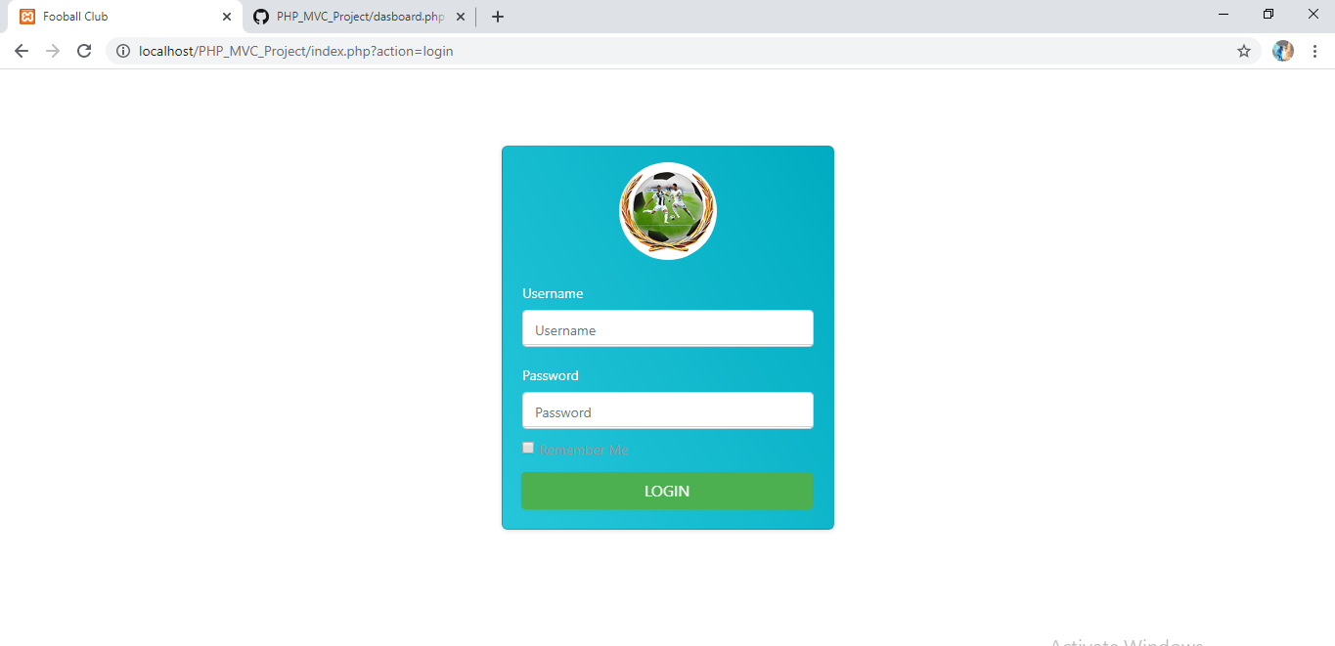

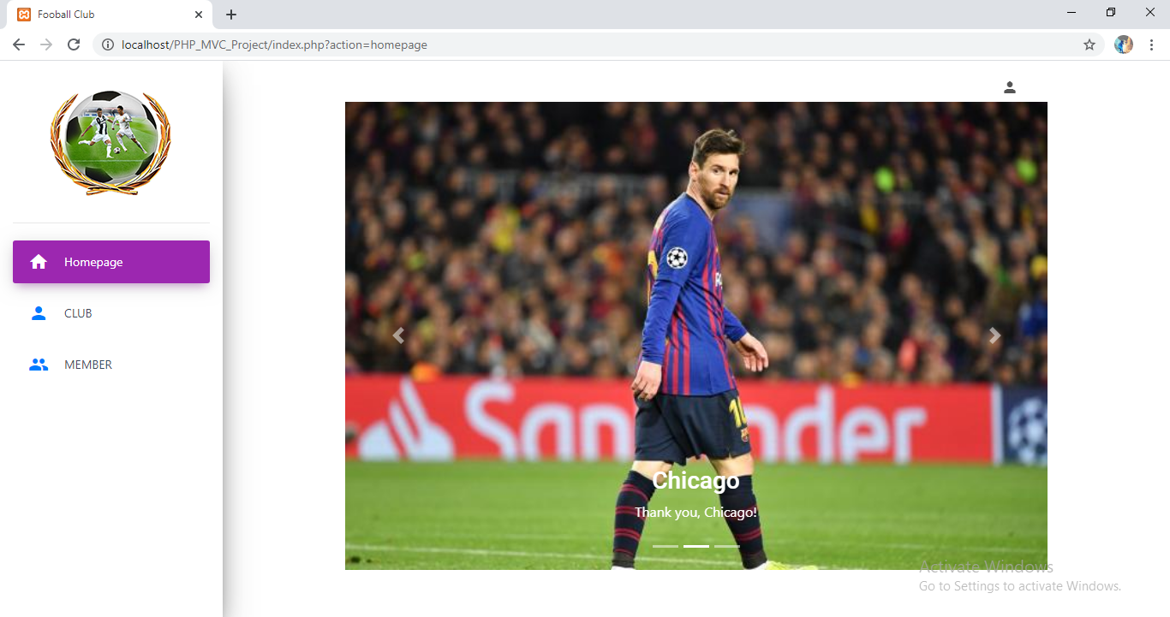

2.Click on club tab users will see list of clubs created and one button for creating club and other Icons such as delete, edit and view to react on club.

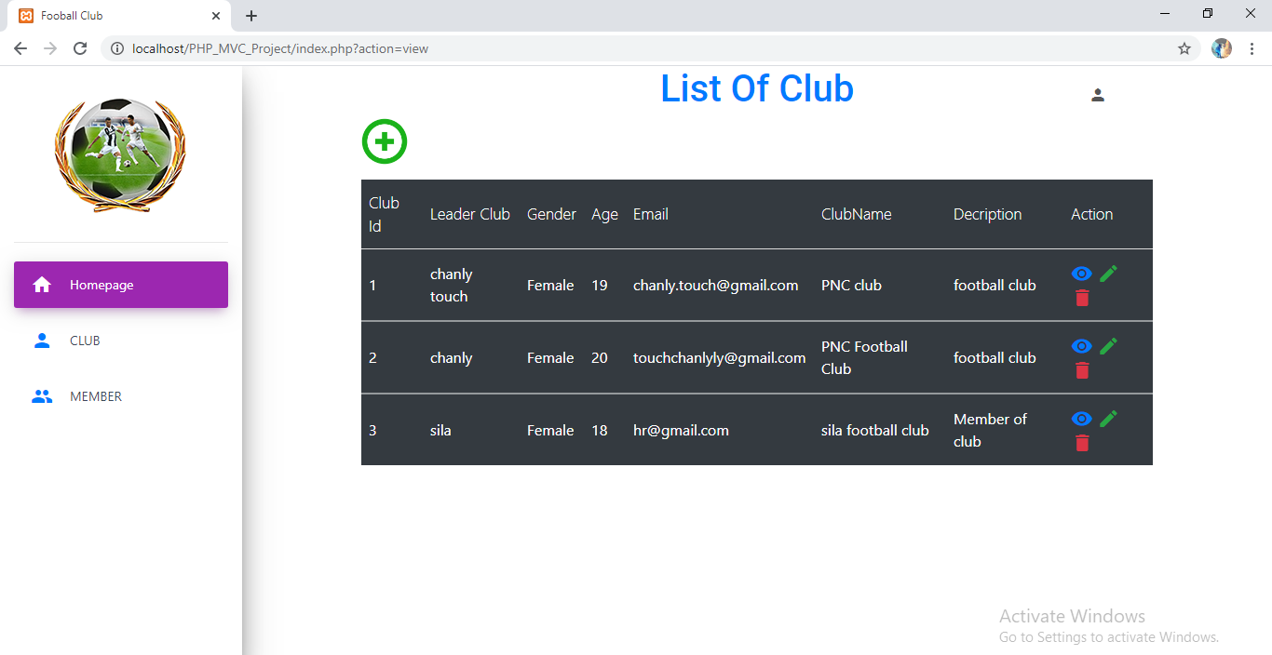

3. Click view icon or member tab, it shows members of club.



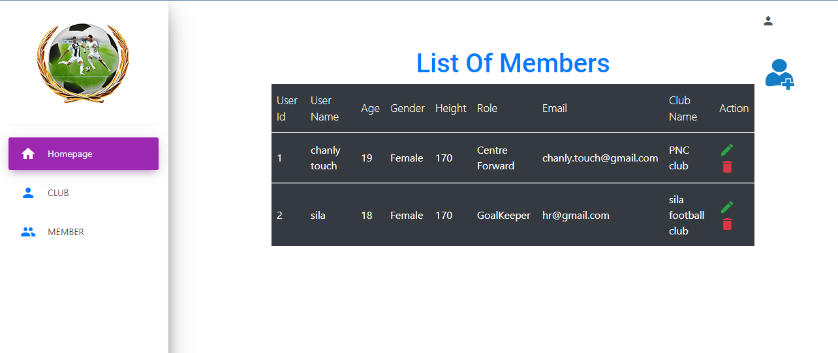4. In view member user can register to be a member of which club that they like. And member who registered they can delete and edit their information also.

5.When user want to know stay in which club, they can click on view icon and member tab they will see all list of the member and users can see the name of club that they registered.